

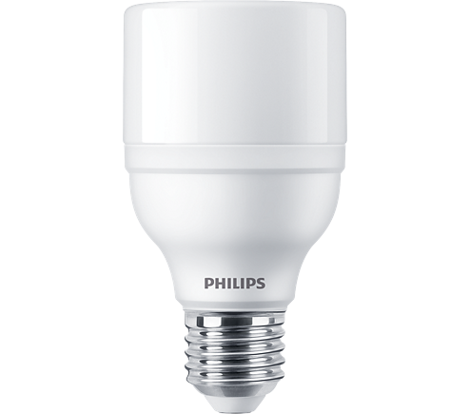

LED BULB

* 20W-145(145W GLS, 35W CFL)W
* E27
* White

**Rs 365.00**